Christian Celebrity Luncheons ......
P.O. Box 911701, St. George, UT, 84790
Telephone: 435-673-4335

CCL has been bringing inspiring Christian speakers and musicians to the country clubs of the Coachella Valley for 32 years. This year will be exceptional!

Make your reservations right away for the Thursday, March 1,
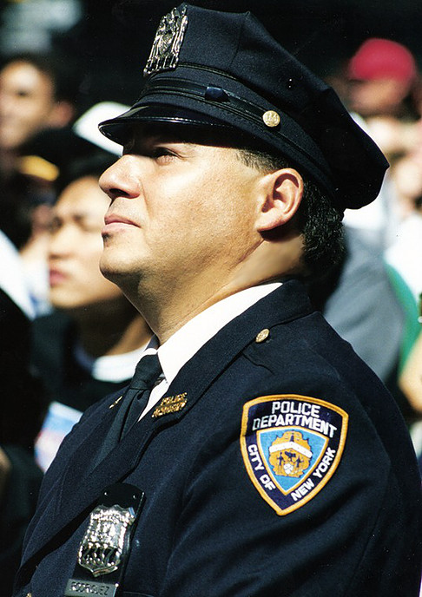
2018, CCL luncheon at Thunderbird Country Club, Rancho
Mirage, CA
Reservations are required.

We have arranged for Daniel Rodriguez, “The Singing Police-
man,” from 9/11, to be our guest celebrity speaker.

We were able to secure Daniel in the midst of his very
busy schedule. He will sing and share his experiences of
that fateful day. His testimony of how God has directed
his life since his heroic participation in the Twin Towers
recues will inspire you. Consider bringing your family and
men friends for this incredible day of this 32nd year of
Christian Celebrity Luncheons.

September 11, 2001, Officer Rodriguez was driving to work when the first plane hit the World Trade Center. Arriving at the site as a first-responder, he witnessed the destruction of both towers, nearly losing his own life.
As it did for all Americans, history intervened for Daniel Rodriguez on Sept. 11, 2001. Like his colleagues, the seven-year veteran of the NYPD stepped up in the aftermath of the terrorist attacks on America, going above and beyond the call of duty to help restore a sense of stability and community. But Rodriguez had something unique to offer in this difficult time, that of the magical effect of his remarkable tenor voice. In a matter of days, his stirring a cappella performance of "God Bless America" and the National Anthem seemed to be something far greater than graceful patriotic gestures. Ringing heartfelt and beautiful, these songs became transcendent statements of solidarity, determination and hope that galvanized his fellow New Yorkers and fellow Americans. Daniel Rodriguez became "America's Beloved Tenor."
Rodriguez has stirred television audiences with appearances on The Today Show, Live with Regis and Kelly, Good Morning America, Larry King Live, Late Show With David Letterman, The World Series, and ABC TV's New Year's Eve with Peter Jennings as well as performances on CNN and at the Macy's Thanksgiving Day Parade and the Christmas Tree lighting Ceremony at Rockefeller Center. Rodriguez also won the admiration of operatic superstar Placido Domingo who invited Rodriguez to study with him at the Washington Opera Company.

Reservations are required... $60.00 per person......There will be no tickets available at the door.
You may call for reservations, using a credit card or send in the following form.

Christian Celebrity Luncheons .......
Thursday, March 1, 2018 Deadline: Friday, February 23, 2018

Your Name ___________________________________________________________Phone _____________________________

Guest _________________________________________________________________ Phone _____________________________

Guest _________________________________________________________________ Phone ____________________________

Guest __________________________________________________________________Phone ____________________________

Guest __________________________________________________________________Phone ____________________________

You may now use your credit card, fill out the form below, and sign it, or send your check. If adding reservations to the card, fill out total on this form below with names above.
For more information or to make your reservation by phone: 435-673-4335
______ Number of reservations for CCL ________total amount at $60.00 per luncheon
Name ________________________________________ Phone ________________________
Address ____________________________________________________________
City ___________________________________ State ______Zip _______________
Card Number _________________________________ Exp. Date __________ CVV code ______
____Visa ____MasterCard _____American Express _____ Discovery
Signature _______________________________________________
Make check to:
Samantha Landy Ministries
P.O. Box 92798
Henderson, Nevada 89009

Make tax-deductible checks: Samantha Landy Ministries, PO Box 911701, St. George, UT 84791

